Roll-2103064
Set-B

- Arithmetic Right Shift:
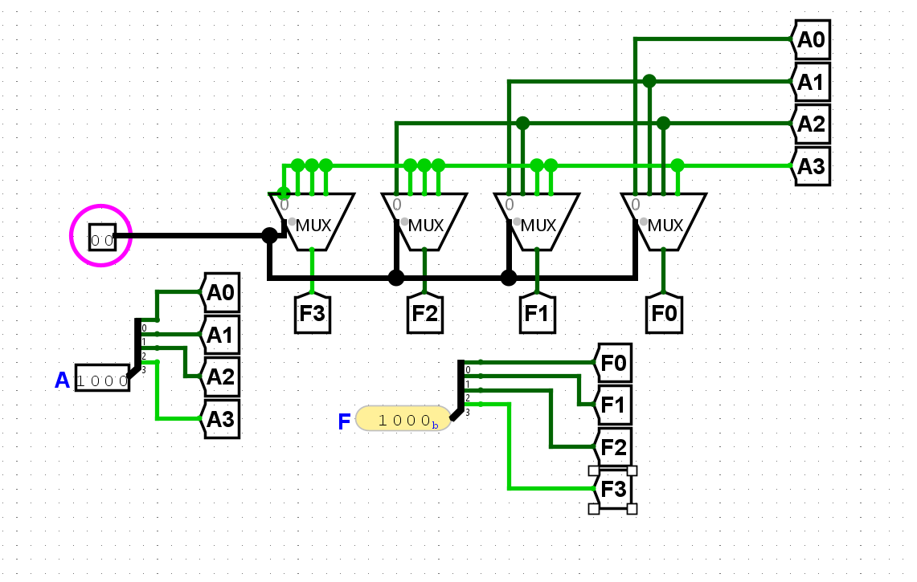

- 4-bit parallel full Subtractor:
#module file:

module sub1 (  input wire A,  input wire B,  input wire Bin,  output reg D,  output reg Bout  );  assign D=A^B^Bin;  assign Bout=Bin&(~(A^B))+(~A)&B;  endmodule | module Full_sub (  input wire [3:0]A,B,  input wire Bin,  output wire [3:0]D,Bout  );  sub1 s1(A[0],B[0],Bin,D[0],Bout[0]);  sub1 s1(A[1],B[1],Bout[0],D[1],Bout[1])  sub1 s1(A[2],B[2],Bout[1],D[2],Bout[2])  sub1 s1(A[3],B[3],Bout[2],D[3],Bout[3])  endmodule

Test_bench file:

`timescale 1ns/1ps
module fs_tb;
reg [3:0]A;
reg [3:0]B;
reg Bin;
wire [3:0]Bout;
wire [3:0]D;

Full_sub uut(A,B,Bin,D,Bout);

initial begin
$dumpfile("test.vcd");
$dumpvars(0,fs_tb);
A=4'b1000;
B=4'b0011;
Bin=0;
#20;

#40;
end

initial begin

$monitor("A=%b, B=%b Bin=%b D=%b Bout=%b",A,B,Bin,D,Bout);
end

endmodule

